
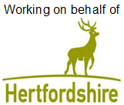

‘Please make sure you have moved your vehicle off the road on the date below’

Resurfacing works in Bull Lane

Works will be carried out from the junction of A507 Baldock Road to just past the entrance to the last house on the right hand side

On Tuesday 6 July 2021
Works between 7:30am and 6:00pm

We are writing to tell you about works we’ll be undertaking in your area.
We know the condition of your road is important to you and it’s important to us too. That’s why we’re investing an extra £37 million over five years to improve the local roads that people live on.
Information about investing in local roads can be seen here www.hertfordshire.gov.uk/localroads
What you need to do:

- We need the road clear of parked vehicles in order to complete the work.

- If you need to use your vehicle, please make sure you move it outside the road closure area shown on this letter, at least 30 minutes before we are due to start working.

- We are able to relocate parked vehicles, if necessary, using a specialist removal vehicle. If you or a member of your household are unable to move a car out of the works area due to shielding, self-isolation or for other reasons, please phone Eurovia on 07703 796403 and we will arrange to have the vehicle professionally relocated free of charge.

What you need to know:
- We would like to reassure you that we are following Government advice relating to construction work and social distancing to minimise the risks related to Covid-19.

- We politely request that all residents respect our workforce and follow social distancing guidance when passing the works area or engaging with our on-site team.

- Vehicles may not be allowed access through the road closure during the works, except for emergency vehicles. We are unable to provide information of which part of the road will have access and when. Please speak to the on-site team on the day who will be able to advise on access or contact the contractor on 07703 796403.

- Where it is safe to do so, the County Council may be able to exercise discretion in exceptional circumstances in order to meet its public sector equality duty.

- Please refer to the yellow signboards on your street to see the exact dates, timings and permit number. Any date changes to these works will be communicated on the yellow signboards at either end of your street and at www.hertfordshire.gov.uk/roadclosures

- These works are weather dependent and may be postponed if poor weather is forecast.
- Details of any disruptions to bus services can be found at www.intalink.org.uk/timetables (search for your service). If you're unable to find this information, please call our customer service centre on 0300 123 4050.

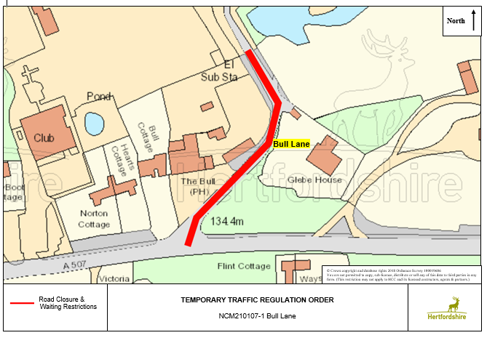

Further information:

- The permit number for these works is BA0080000006385 full details can be found at www.one.network

- If you have any special needs or circumstances, please contact Eurovia on 07703 796403 or HCC.Comms@eurovia.co.uk or CSC on 0300 123 4047 or email us at cschighways@Hertfordshire.gov.uk

We understand these works may be an inconvenience to you, however, we ask you to support us as we make the necessary improvements.

To hear live traffic information and news across Hertfordshire, please follow us on social.



@HertsHighways @HertsHighways @Herts_Highways

