

‘Please ensure you have moved your vehicle on the date below’
Footway Micro-surfacing in A507 Cottered

Between The Crescent To layby west of Peartree Cottage

Between Friday 24 September and Monday 27 September
Works between 09:30am and 3:30pm

We are writing to tell you about works we’ll be undertaking in your area.

These repairs have been recommended as a priority by your County Councillor Jeff Jones and are funded using the Highways Locality Budget.
Information about locality budgets can be seen here www.hertfordshire.gov.uk/localitybudgets

What you need to do:

- If you need to use your vehicle, please make ensure you move it outside the area shown on this letter, at least 30 minutes before we are due to start working

What you need to know:

- Vehicles may not be allowed access through during the works, except for emergency vehicles. We are unable to provide information of which part of the road will have access and when. Please speak to the on-site team on the day who will be able to advise on access Rejuvo JPCS on 01948 820696 during office hours 09.00 – 5.00

- Where it is safe to do so, the County Council may be able to exercise discretion in exceptional circumstances in order to meet its public sector equality duty.

- Please refer to the yellow signboards on your street to see the exact dates, timings and permit number. Any date changes to these works will be communicated on the yellow signboards at either end of your street and at www.hertfordshire.gov.uk/roadclosures

- These works are weather dependent and may be postponed if poor weather is forecast.

- Details of any disruptions to bus services can be found at www.intalink.org.uk/timetables (search for your service). If you're unable to find this information, please call our customer service centre on 0300 123 4050.

- All local businesses will be open as usual.
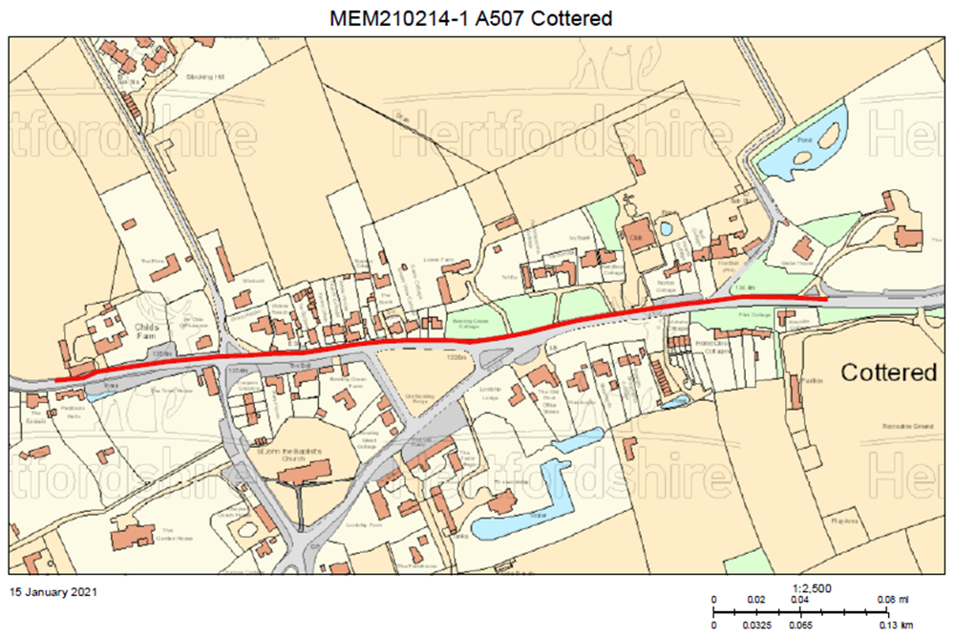

Further information:

- The permit number for these works is FM102MEM210214-1-02-01

- If you have any special needs or circumstances, please contact customercare@rejuvo.com or CSC on 0300 123 4047 or email us at cschighways@Hertfordshire.gov.uk

We understand these works may be an inconvenience to you, however, we ask you to support us as we make the necessary improvements.

For live traffic information and news across Hertfordshire, please follow us on social.




@HertsHighways @HertsHighways @Herts_Highways

